Proposed state fee would end solar savings

by Jon Wellinghoff and Daniel Kammen

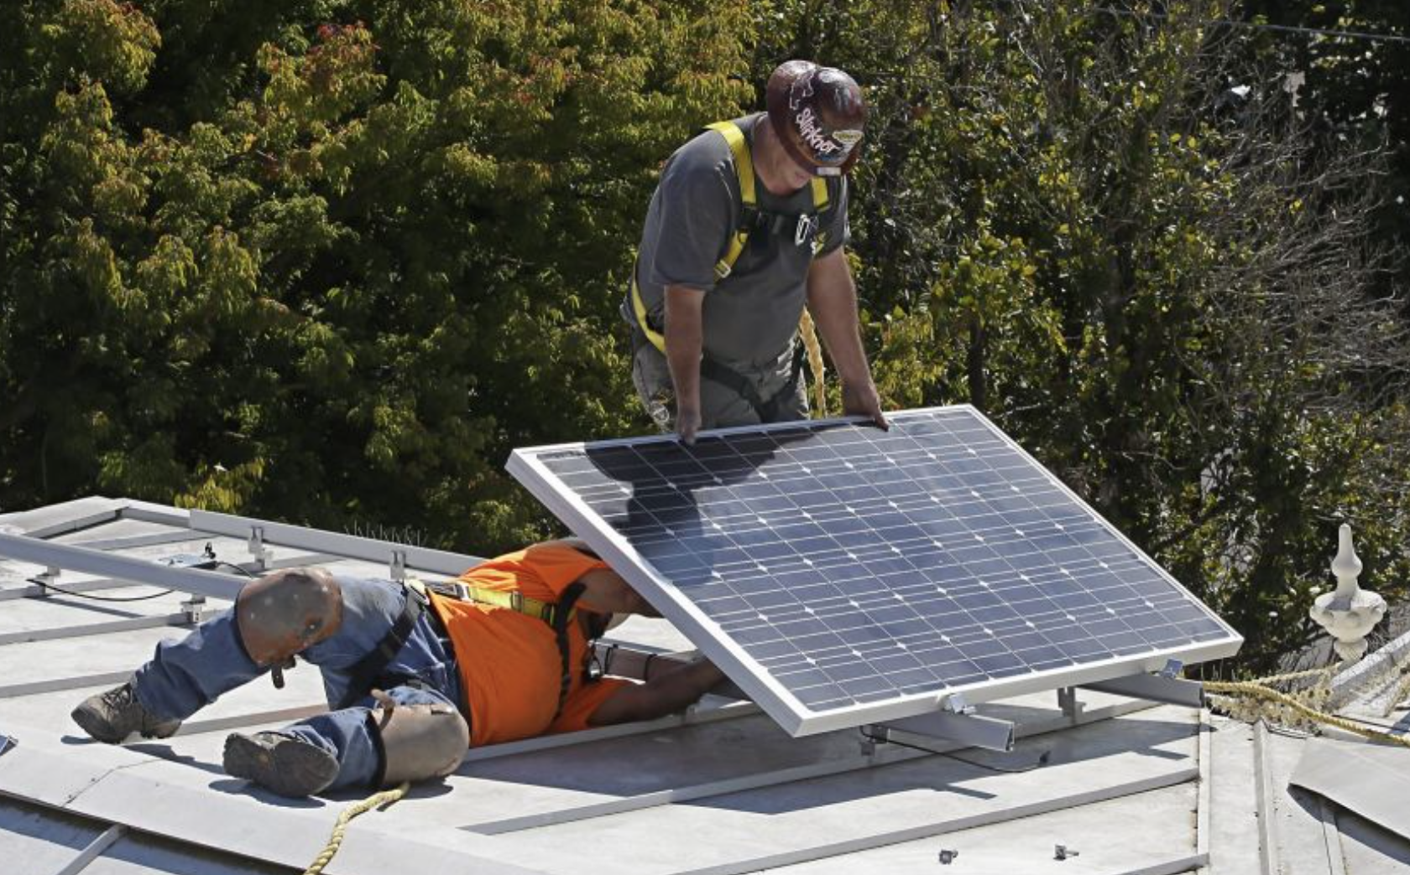

Photo: Rich Pedroncelli, Associated Press
A solar panel is installed in mid-October on the roof of the Governor’s Mansion State Historic Park in Sacramento.

California consumers are embracing rooftop solar with practical enthusiasm, bringing the state halfway toward its goal of a million solar rooftops by 2020. New rules proposed by a state agency, however, would impose fees that would wipe out the savings of solar, effectively ending customer choice for middle-class California ratepayers.

Whether Californians continue to have the choice to generate some of their power from solar panels is now up to the California Public Utilities Commission, which is expected to issue new rules in coming weeks. Sadly and predictably, the state’s largest private utilities have asked the commission to end the state’s net energy metering policy because solar rooftops are deemed competition that threatens the century-old monopoly utility business model.

What is surprising to us, however, is the proposal coming from the state’s Office of Ratepayer Advocates, the independent entity within the commission that advocates on behalf of ratepayers. The office is advocating monthly fees on new solar customers that are more extreme than those sought by the most anti-rooftop-solar utilities.

When I was the consumer advocate in Nevada prior to serving as the Federal Energy Regulatory Commission chairman, I understood my role to include advocacy for the ratepayers of today as well as those of the future. I knew it was vital to update how we think about the role of utilities and where we get our energy. My co-author, Daniel Kammen, runs an internship program with the Office of Ratepayer Advocates, where analytic capacity exists to support cutting-edge analysis of costs and benefits of rooftop solar. So far the office has failed to do so.

We know the proposal:

•Would destroy a huge portion of potential electric bill savings from installing solar. It would have the typical residential solar customer pay additional fixed charges of $50 to $70 each month — simply for buying less utility power by going solar. The charge, which depends on the size of the solar system, would escalate over time from $2 per kilowatt to $10 per kilowatt.
Arizona Public Service, the largest utility in Arizona and one notoriously hostile to rooftop solar, recently proposed increasing its ill-considered installed capacity fee from 70 cents per kilowatt to $3 per kilowatt — and then quickly withdrew the proposal in the face of public opposition. It troubles us that California’s official ratepayer advocate appears to be taking its cue from Arizona utilities and then seeking antisolar charges far beyond what those utilities even dared to propose.

California consumers are embracing rooftop solar with practical enthusiasm, bringing the state halfway toward its goal of a million solar rooftops by 2020. New rules proposed by a state agency, however, would impose fees that would wipe out the savings of solar, effectively ending customer choice for middle-class California ratepayers.

Whether Californians continue to have the choice to generate some of their power from solar panels is now up to the California Public Utilities Commission, which is expected to issue new rules in coming weeks. Sadly and predictably, the state’s largest private utilities have asked the commission to end the state’s net energy metering policy because solar rooftops are deemed competition that threatens the century-old monopoly utility business model.

What is surprising to us, however, is the proposal coming from the state’s Office of Ratepayer Advocates, the independent entity within the commission that advocates on behalf of ratepayers. The office is advocating monthly fees on new solar customers that are more extreme than those sought by the most anti-rooftop-solar utilities.

When I was the consumer advocate in Nevada prior to serving as the Federal Energy Regulatory Commission chairman, I understood my role to include advocacy for the ratepayers of today as well as those of the future. I knew it was vital to update how we think about the role of utilities and where we get our energy. My co-author, Daniel Kammen, runs an internship program with the Office of Ratepayer Advocates, where analytic capacity exists to support cutting-edge analysis of costs and benefits of rooftop solar. So far the office has failed to do so.

We know the proposal:
• Would destroy a huge portion of potential electric bill savings from installing solar. It would have the typical residential solar customer pay additional fixed charges of $50 to $70 each month — simply for buying less utility power by going solar. The charge, which depends on the size of the solar system, would escalate over time from $2 per kilowatt to $10 per kilowatt.

Arizona Public Service, the largest utility in Arizona and one notoriously hostile to rooftop solar, recently proposed increasing its ill-considered installed capacity fee from 70 cents per kilowatt to $3 per kilowatt — and then quickly withdrew the proposal in the face of public opposition. It troubles us that California’s official ratepayer advocate appears to be taking its cue from Arizona utilities and then seeking anti-solar charges far beyond what those utilities even dared to propose.

• Ignores the many ways rooftop solar provides savings for all ratepayers, whether or not they install solar.

For example, when rooftop solar produces energy on hot summer days, it alleviates the need to run (and utilities to purchase power from) inefficient natural gas “peaker” plants. Because the most expensive plant sets the price paid, the savings to ratepayers from reducing electricity demand are substantial. Neither these savings nor the direct financial benefit of lowering the exposure to volatile natural gas prices was considered.

• Would stifle the market for emerging technologies. The Office of Ratepayer Advocates could be looking for ways to make the electric grid more efficient and benefit ratepayers California is the nation’s undisputed leader in solar power and, given the state’s ambitious clean energy goals, our state regulators must be bold and forward-thinking. The Office of Ratepayer Advocates claims its proposal promotes solar, but it would restrict rooftop solar to only the wealthy — and deprive all California ratepayers of more local jobs, cleaner air, reduced climate impacts, a more resilient grid and other societal benefits.

For more than 100 years, consumers have had no choice but to purchase their electricity from the monopoly utility. Without competition, utilities lack the full incentive to innovate and to reduce their costs and pass the savings on to consumers. This leads to electric rates that rise continuously. To protect electric ratepayers, the Office of Ratepayer Advocates and the Public Utilities Commission should support innovation and healthy competition in the power industry that will result in cheaper, cleaner and safer electricity for all ratepayers.

Jon Wellinghoff, a lawyer, is the former chairman of the Federal Energy Regulatory Commission and Nevada’s first Advocate for Customers of Public Utilities. Daniel Kammen is a professor of energy in the Energy and Resources Group and in the Goldman School of Public Policy at UC Berkeley. Twitter: @dan_kammen

To comment, submit your letter to the editor at www.sfgate.com/submissions.

California solar

450,000

The number of solar rooftops in California, out of 650,000 installed nationwide
50 percent

The 2030 goal for the portion of the state’s energy portfolio from solar, wind, biomass and geothermal energy sources

$50 to $70 a month

The “installed capacity fee” the Office of Ratepayers Advocates proposes tacking onto solar customers’ electric bill

