October 19, 2016 – The Beam Interview: Daniel Kammen

“Clean energy systems can be significant levers to promote social equity.”
Daniel Kammen earned a bachelor’s degree in physics at Cornell and master’s and doctoral degrees in physics at Harvard. Today he is a professor in both the Energy Resources Group and the Goldman School of Public Policy at UC Berkeley, where he also directs the Renewable and Appropriate Energy Laboratory (RAEL). He was a coordinating lead author for the Intergovernmental Panel on Climate Change (IPCC), which won the 2007 Nobel Peace Prize. In all these endeavors, Kammen is working to overcome a lack of basic energy resources and inefficient and unsustainable energy practices — problems that he believes may be the largest contributors to human, environmental, and global health problems today.

The Beam: What is the Renewable and Appropriate Energy Laboratory (RAEL: rael.berkeleh.edu) and what is its goal?
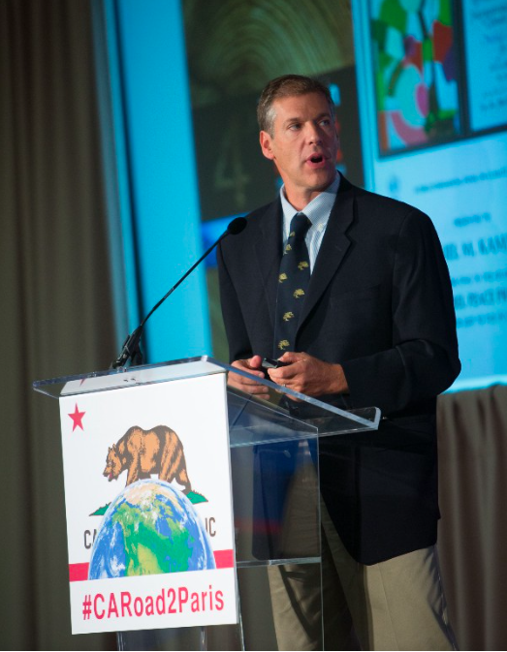
Daniel Kammen: RAEL is a research and implementation group focused on developing new techniques to examine the benefits and costs of decarbonization and energy access strategies for homes, cities, nations and regions. Specific RAEL projects focus on elements of this continuum for energy access for the poor, notably in East Africa, Central America, and in South East Asia, for community sustainability, and for decarbonizing entire power grids. The power grid model, SWITCH, is in widespread use, in the US, China, Kenya, Chile, Nicaragua, with versions for India and Mexico under development.
How can the transition to a clean energy landscape reduce social inequalities? How do you envision this happening?
Clean energy systems can be significant levers to promote social equity. The non-rival nature of many clean energy systems is an important part of that story, but so is understanding and acting to address the environmental injustices of energy inequality and pollution clustered where poor and minority groups live.
My own laboratory has a major international program in using clean energy initiatives to address conflict in areas such as South Sudan, Myanmar, inner-city US locations, and can be found at:
https://rael.berkeley.edu/conflict/
In our second edition of The Beam, we interviewed Thomas Gottschalk, the CEO of Mobisol, a German company that provides solar home systems to remote population in Africa thanks to a-pay-as-you-go system. How important are these micro-grid initiatives?
Mobisol is a great example — along with M-KOPA, BBOXX and many other off-grid and pay-as-you-go solutions. Technology has been needed for this change, but even more important is the shift of mindset from centralized to decentralized and accessible.
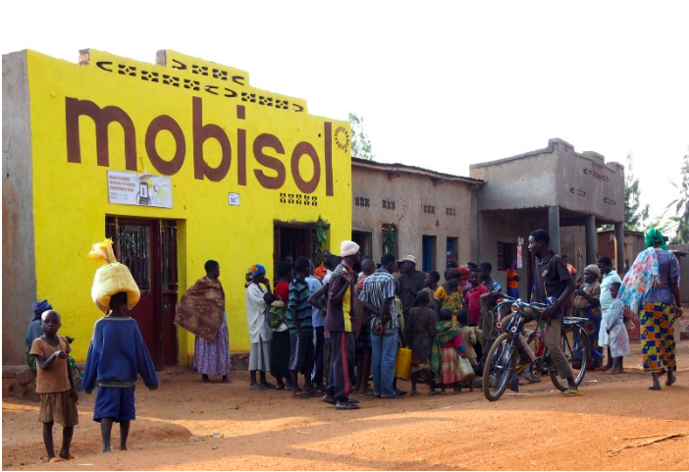
RAEL (rael.berkeley.edu) is studying low-carbon transition scenarios for both the US and Chinese power sectors, how is international cooperation important for clean energy transition? What needs to happen on a geopolitical level in order to facilitate international cooperation in the energy sector?
Very simply and directly: shared grid systems take advantage of the geographic diversity that makes renewables easier to forecast, and shared infrastructure promotes cooperation.
Politicians are often accused, by experts, of legislating too slowly, creating a delay between policy and the real world. Is this a problem for a clean energy transition? How optimistic are you about this transition?
I am very optimistic because the clean, distributed energy system can simply be better in terms of price, job-creation, reliability and impact. The problems, however are that we have been far too mild and slow to send a clear price signal through a carbon price (not necessarily event a ‘tax’; it could be offset by lowering other taxes, notably those on things we WANT, such as employment and creating capital.
According to your research, why is fossil fuel such a bad idea to fight poverty?
Fossil fuels are both destructive to the wider economic and environmental system, but more directly are resources that lend themselves to aggregation and monopolies. Monopolies typically under-innovate robbing us of the best features of a market-based system.
How does solar power generate social change?
One of the most important aspects of renewable energy is that the resource can be shared; and that the use of one community does not generally impact others (true for solar and wind, a bit more complex for hydropower) ability to use the same resource. That means that well-designed clean energy systems can actually become vehicles to share resources more equitably (e.g. community mini-grids, or apartment buildings with shared rooftop solar). As always financing is an issue where the traditionally disadvantaged need more support, but with the costs of clean energy up front, the route exists to set up new infrastructure to directly support poor individuals and communities.
Interview by Anne-Sophie Garrigou

