The Beautiful Rivers—And the Dammed

Advances in solar and wind power mean that hydropower is no longer the only renewable game in town—and that’s good news for the world’s rivers.
BY JEFF OPPERMAN, CHRIS WEBER, DANIEL KAMMEN

NOVEMBER 23, 2018, 9:05 AM

Foreign Policy

https://foreignpolicy.com/2018/11/23/the-beautiful-rivers-and-the-dammed/

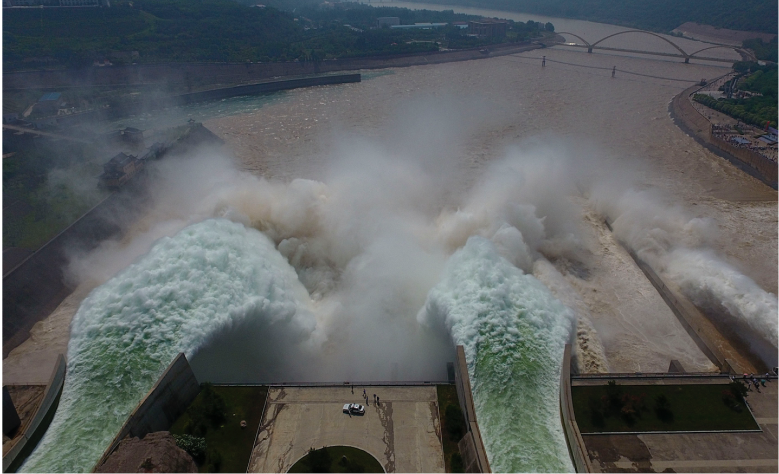
Figure: Water is released from the floodgates of the Xiaolangdi dam on the Yellow River near Luoyang, China on June 29, 2016. (STR/AFP/Getty Images)

In October, the Intergovernmental Panel on Climate Change released a report outlining strategies the world can pursue to keep global warming below 1.5 degrees Celsius and maintain healthy economies and ecosystems. But unless we are smart about how we implement that blueprint, it could cause irreparable damage to the world’s great rivers.
The panel’s report urges a rapid transition to low-carbon, renewable sources of electricity. That call to action could trigger expanded investment in hydropower, which is currently the world’s main source for that kind of energy (70 percent as of 2017). But if that development follows the pattern of earlier dam-building, it could accelerate an alarming loss of rivers and their resources, including of the fish that feed hundreds of millions of people.
The case of the Mekong River puts the problem into sharp relief. The river is the world’s most productive freshwater fishery—it provides nearly 20 percent of the annual global freshwater fish harvest, the primary source of protein for tens of millions of people in the region. Already, several hydropower dams on the Mekong are under construction or are moving through the planning process. Scientists estimate that those dams, if completed, will cut the river’s annual harvest by half.
With the Mekong Delta’s sand supply cut off, scientists project that it will sink and shrink, with more than half underwater by the end of the century.
The dams are also projected to trap within their reservoirs more than 90 percent of the sand that would otherwise flow into the Mekong Delta, which is home to 17 million people and produces 90 percent of Vietnam’s rice exports. With its sand supply cut off, scientists project that the delta will sink and shrink, with more than half underwater by the end of the century.
It is easy to hear such stories and conclude that the world faces an agonizing dilemma: Must we sacrifice our rivers to save our climate? Even just a few years ago, that trade-off seemed unavoidable. With wind and solar power limited by their expense and variability, global hydropower was projected to nearly double by 2050. Massive dams were under construction or planned for many of the world’s great rivers, including the Yangtze, Mekong, and most tributaries of the Amazon. Some governments used climate and renewable energy objectives to justify these projects, even as scientists quantified their impacts and affected communities and indigenous groups protested.
But we do not need to sacrifice rivers for zero-carbon energy. In the last two years, solar energy has rapidly become more economically viable due to technological improvements and to economies of scale in production and deployment. Whereas solar energy used to cost 20 cents or more per kilowatt-hour, new projects in Chile, Mexico, and Saudi Arabia have come in at one-tenth that cost. Wind energy costs have likewise plummeted. In 2017, a winning bid for a new wind farm in Mexico featured costs of around 2 cents per kWh. That was half the previous year’s lowest bid there. This makes solar and wind the price leaders across much of the world.
Even with falling costs, the variability of wind and solar power remain a challenge. Simply put, in order for these technologies to offer reliable, round-the-clock electricity generation, there needs to be a way to store power when the wind is blowing and the sun is shining and then deploy it when the wind dies down or the sun sets.
Fortunately, the costs for storage technologies are plummeting as well, with the cost of lithium ion batteries, capable of grid-scale storage, dropping by about 90 percent over the past few years. New technologies are emerging as well. For example, a Chilean solar power plant that uses molten salt as storage recently offered to provide 24-hour baseload electricity at less than 5 cents per kWh. That is comparable to or cheaper than most hydropower and fossil fuel options. Tesla and Google X, meanwhile, are pursuing “moonshot” solutions for storage technologies.
Also tipping the scales toward wind and solar is that, among large infrastructure projects, hydropower dams have among the worst performance in terms of delays and cost overruns, in part due to the conflict and controversy surrounding them. Whereas some dams take a decade to complete, wind and solar power can be delivered through rapid, smaller-scale, and lower-risk projects that tend to engender far less conflict.
Governments are taking note. Thailand earlier this year signaled that it would delay signing a power purchase agreement for Pak Beng, a 912-megawatt hydropower dam that Laos is planning for the Mekong. In announcing the delay, the country stated that it needed to revisit its energy strategy since other renewable sources, including wind and solar, were becoming increasingly viable. Thailand was slated to buy 90 percent of the dam’s electricity, so its change of plans could spell the end of the project. In Guyana, meanwhile, rising cost estimates and delays for the Amaila Falls hydropower project led the government and financiers to transfer funding intended for the dam toward a 100-megawatt solar project.
The rapidly evolving renewable energy landscape doesn’t mean an end to hydropower, but rather a shift in its role. Hydropower reservoirs are currently the dominant form of energy storage for grids, and although other forms of storage are improving, they will continue to provide critical storage services in the near future. Upgraded older dams and strategically planned new projects, carefully located to minimize environmental and social disruption, can emphasize energy storage to facilitate adding large increments of wind and solar into a grid.
Although it is now possible to build affordable, low-carbon wind and solar systems, they still face constraints, including political and social preferences for large infrastructure projects. Pak Beng may have been paused, but other dam projects on the Mekong and on other key rivers are moving forward.
It would be a great tragedy if the renewable revolution arrived just a few years too late to save the world’s great rivers. Market reforms and new financial mechanisms can accelerate the adoption of more sustainable energy systems, as can innovative science. For example, the Renewable and Appropriate Energy Laboratory at the University of California, Berkeley recently developed and is using an energy planning model for Laos. The lab found that investments in solar panels (backed up by existing hydropower) could meet that nation’s objectives for selling electricity to neighbors—with greater returns and lower risks than the planned dams that threaten the Mekong’s fish harvests and the viability of its delta.
There’s no need to continue accepting tragic trade-offs between healthy rivers and low-cost, reliable, and renewable electricity. The renewable revolution provides an opportunity to have both. Governments, funders, developers, and scientists should seize it.
Jeff Opperman is the World Wildlife Fund’s global lead scientist for freshwater. Twitter: @jjopperman
Chris Weber is the World Wildlife Fund’s global lead scientist for climate and energy.
Daniel Kammen is a professor in and the chair of the Energy and Resources Group and a professor of public policy at the University of California, Berkeley. He has been a coordinating lead author for the Intergovernmental Panel on Climate Change and a science envoy for the U.S. State Department. Twitter: @dan_kammen

Foreign Policy

https://foreignpolicy.com/2018/11/23/the-beautiful-rivers-and-the-dammed/

