Why Housing Policy Is Climate Policy

Appeared in The New York Times, March 25, 2019
In California, where home prices are pushing people farther from their jobs, rising traffic is creating more pollution.
By Scott Wiener and Daniel Kammen
Senator Wiener is the chairman of the California Senate’s Housing Committee. Dr. Kammen is a professor of energy at the University of California, Berkeley.

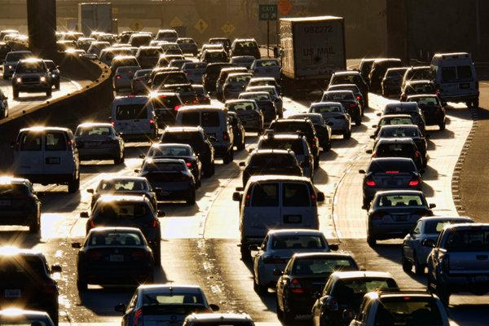
CreditRichard Vogel/Associated Press
California has long been seen as a leader on climate change. The state’s history of aggressive action to reduce air pollution, accelerate the use of renewable energy and speed the transition to a low-carbon, climate-resilient economy has inspired governments around the world to set more ambitious climate goals.
But there is trouble on the horizon, and California’s climate leadership is at risk.
Across most of the state’s economy, greenhouse gas emissions have been trending steadily down. But ballooning car traffic on city streets and freeways is negating much of that progress. In California, about 40 percent of greenhouse gas emissions are from transportation, and they are increasing. In some California counties, two-thirds of emissions are from vehicles.
In November, the California Air Resources Board released an updateon efforts to reduce pollution from transportation. The numbers were alarming. Despite headlines about California’s push for more electric vehicles, pollution from cars is still climbing. “With emissions from the transportation sector continuing to rise, California will not achieve the necessary greenhouse gas emissions reductions to meet mandates for 2030,” the board warned.
The solution? “Significant changes to how communities and transportation systems are planned, funded and built,” the board said.
ADVERTISEMENT
Put more directly, in order to solve the climate crisis, we have to solve the housing crisis.
Numerous climate researchers have a similar conclusion. In an assessment of the carbon footprint of 700 California cities, experts with the Renewable and Appropriate Energy Laboratory at the University of California, Berkeley, including one of us (Dr. Kammen), found that, for most coastal California cities, “infill” housing — that is, housing built in urban areas, near transit, jobs and services — can reduce greenhouse gas pollution more effectively than any other option.
Other research has confirmed this work, and bolstered the case for using denser housing and public transportation as weapons against climate change.
The relationship between housing and transportation emissions is not complicated. The housing crisis in our cities and job centers — California is short 3.5 million homes, according to a report by the McKinsey Global Institute — is forcing more workers to “drive till they qualify,” the term used by real estate agents for what a growing number of Californians have to do to find housing they can afford. As cities that are job centers make it hard or impossible to build housing — for example, through de facto bans on apartment buildings in areas zoned for single-family homes — people who are priced out move further away, resulting in sprawl that covers up farmland and open space, clogs freeways and increases greenhouse gas emissions.

Cities With the Most ‘Super-Commuters’
Of the 100 largest U.S. metropolitan areas, these are the 20 with the greatest proportion of residents working full-time who spend 90 minutes or more getting to their jobs. (Nationally, 72 percent of these super-commuters drive.) Eight of these areas are in California; the San Francisco area has seen the most growth in ultra-commuters since 2005.
The results are anything but equitable. By making housing shockingly expensive near jobs and transit, cities force low-income and working-class people to live far away from where they work. Our communities lose their economic diversity, while the abundant opportunities, services and neighborhood amenities of cities are walled off to all but the very wealthy.
Low-density, single-family-home zoning is effectively a ban on economically diverse communities.
Californians need more and better alternatives to cars for transportation, and easier access to walkable communities and affordable housing near mass transit. Of course, we also have to accelerate the electrification of our vehicles, another way to reduce pollution from cars. But, as the air resources board has found, electrification alone cannot happen fast enough to solve the problem, and we need to reduce the number of miles people drive by 25 percent.
In his first major speech since taking office, Gov. Gavin Newsom placed solving the housing crisis at the top of his agenda. Under his proposed budget, cities that don’t build enough housing will lose state transportation funding.
And this legislative session, a bipartisan coalition of California legislators is supporting the More Homes Act, which is sponsored by one of us (Senator Wiener). The bill would override local restrictive zoning by legalizing small to midsize apartment buildings (up to five stories) near job centers and public transportation and set minimum affordability standards for some of those units. The legislation would also help existing renters keep their homes in areas that qualify for new housing. The measures are intended to stem the growth of super-commuters — workers who are priced out of areas near their jobs and forced to drive long distances to get to work.
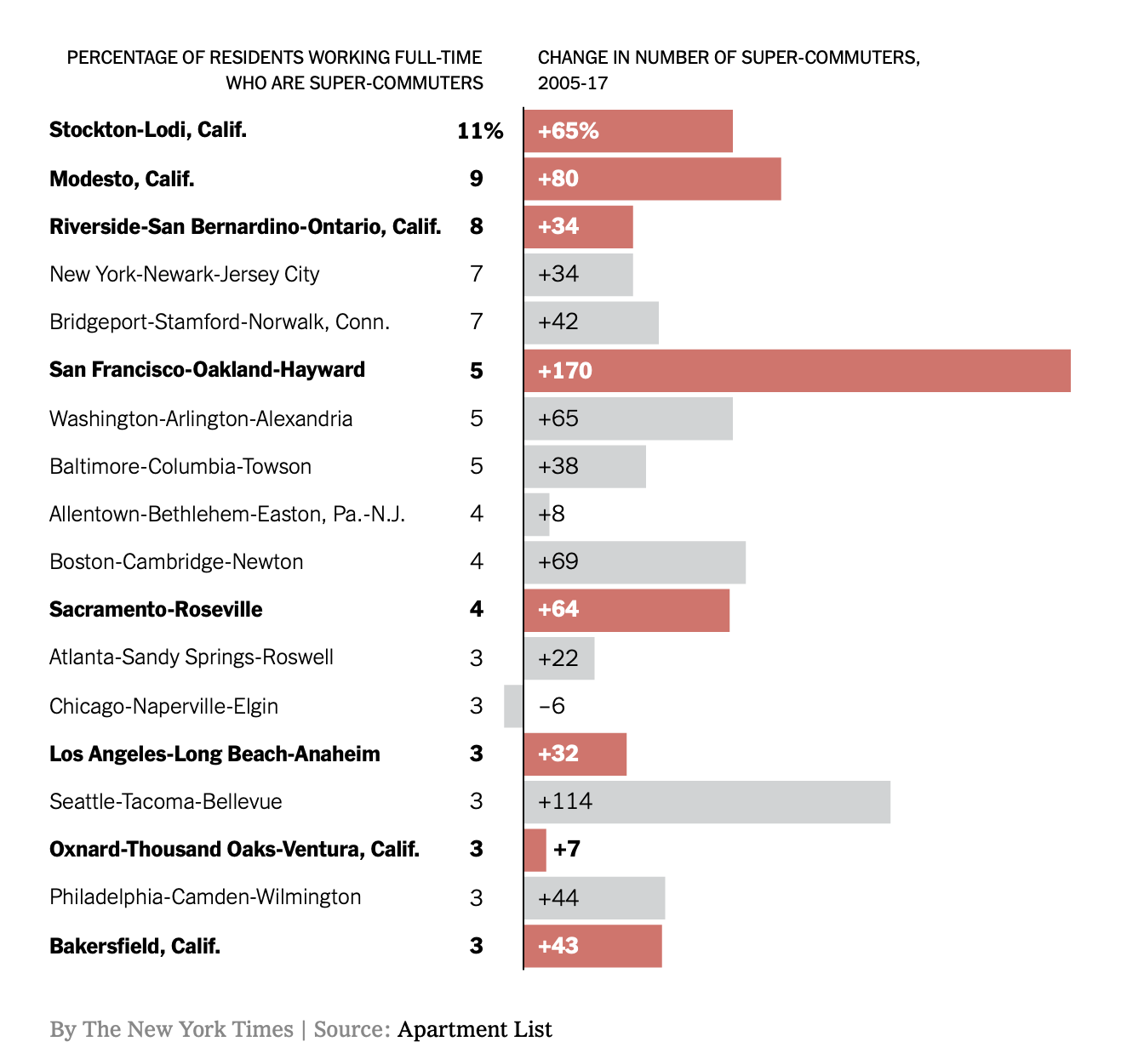
Cities across the United States face issues similar to those in California, too many of which have largely closed the doors to new residents — only to force them into similar patterns of crushing commutes and worsening pollution.
Measures like the More Homes Act offer a road map to cities and states that want to address these issues head-on. In fact, we’d argue that surging interest in urban housing and transportation issues, and the rise of the grass roots Yes in My Back Yard movement that’s behind it, is perhaps the most hopeful development in the American climate movement in recent years.
Unlike many of our climate policy challenges, housing and transit are largely controlled by cities and states. If we can build more momentum for more homes near transit and jobs, we can continue to reduce greenhouse gas emissions, in California and around the country, and make sure our progress continues apace.
Scott Wiener, a Democrat, represents San Francisco in the California Senate, where he is chairman of the Housing Committee. Daniel Kammen is a professor and chair of the Energy and Resources Group, and a Professor in the Goldman School of Public Policy, and a Professor in the Department of Nuclear Engineering at the University of California, Berkeley. Kammen served as Science Envoy for the US Department of State.

